Name: Salma Gamal Atia
B.N: 395
Topic: Cryptography
Githup linke: https://github.com/salma-gamal/HTML-project-repository
githup pages published websight: https://salma-gamal.github.io/HTML-project-repository/index.html

Application Brief:

Conventionally, cryptography was in implementation only for securing purposes. Wax seals, hand signatures and few other kinds of security methods were generally utilized to make sure of reliability and accuracy of the transmitter. And with the arrival of digital transmissions, security becomes more essential and then cryptography mechanisms began to outstrip its utilization for maintaining utmost secrecy. A few of the applications of cryptography are discussed below.

To Maintain Secrecy in Storage
Cryptography allows storing the encrypted data permitting users to stay back from the major hole of circumvention by hackers.

Reliability in Transmission
A conventional approach that allows reliability is to carry out a checksum of the communicated information and then communicate the corresponding checksum in an encrypted format. When both the checksum and encrypted data is received, the data is again checksum and compared to the communicated checksum after the process of decryption. Thus, effective cryptographic mechanisms are more crucial to assure reliability in message transmission.

Authentication of Identity
Cryptography is strongly linked to the approach of using passwords, and innovative systems probably make use of strong cryptographic methods together with the physical methods of individuals and collective secrets offering highly reliable verification of identity.

Screenshots:
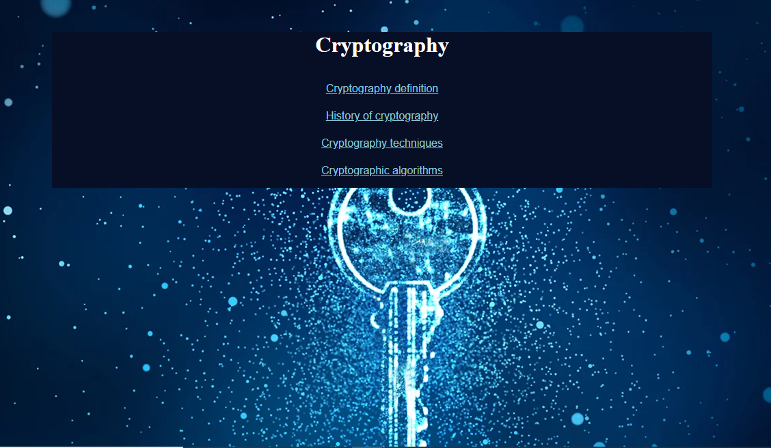
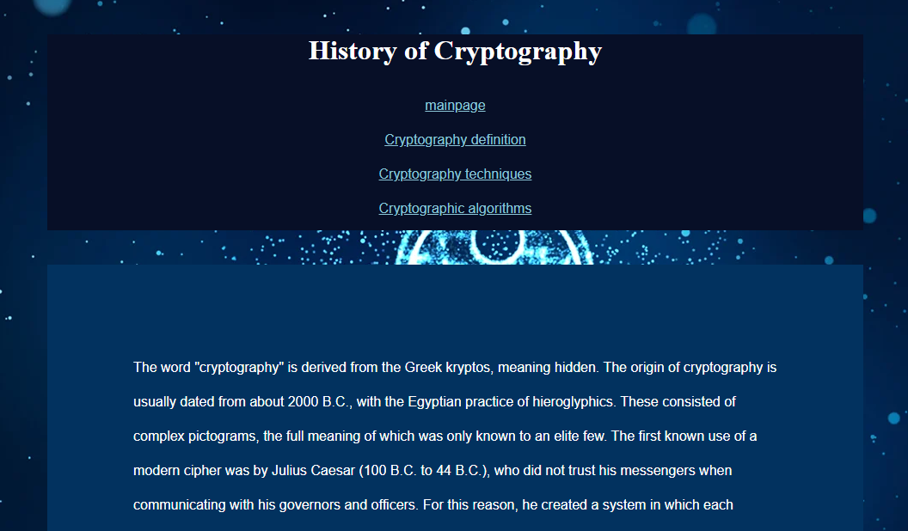
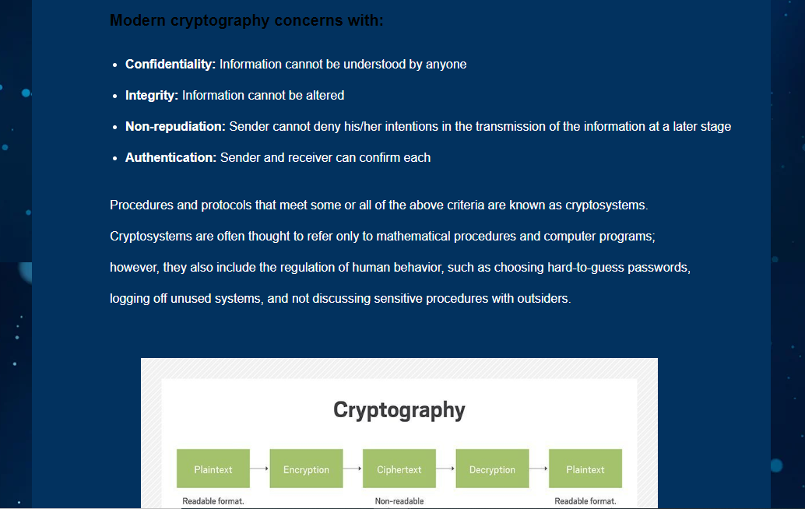
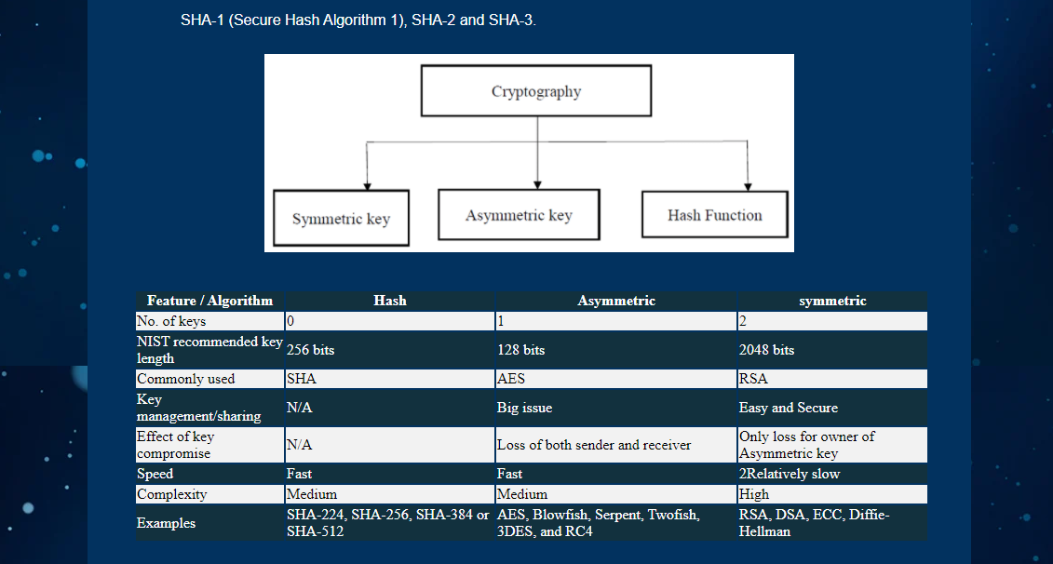

Source Code:

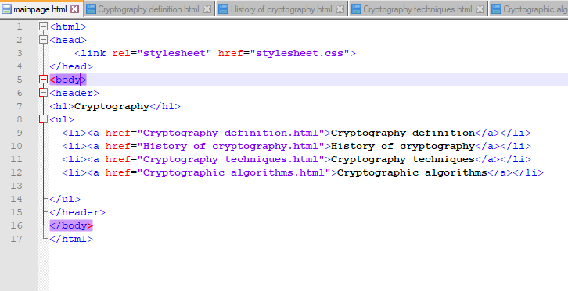
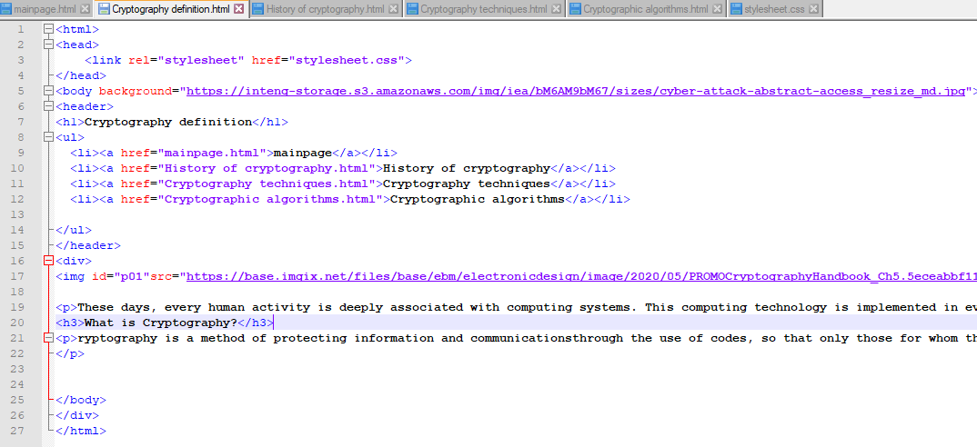
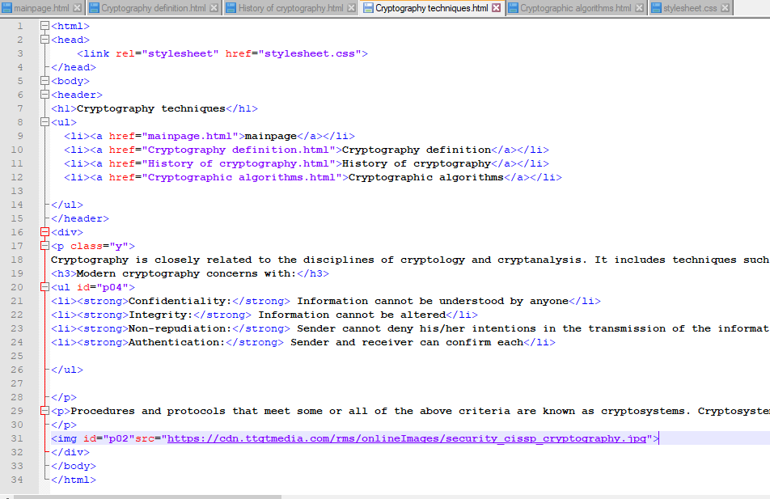

References:

- https://www.elprocus.com/cryptography-and-its-concepts/
- https://www.cryptomathic.com/news-events/blog/differences-between-hash-functions-symmetric-asymmetric-algorithms
- https://searchsecurity.techtarget.com/definition/cryptography

